What are basic components of computer hardware?
There are several basic components of computer hardware including:
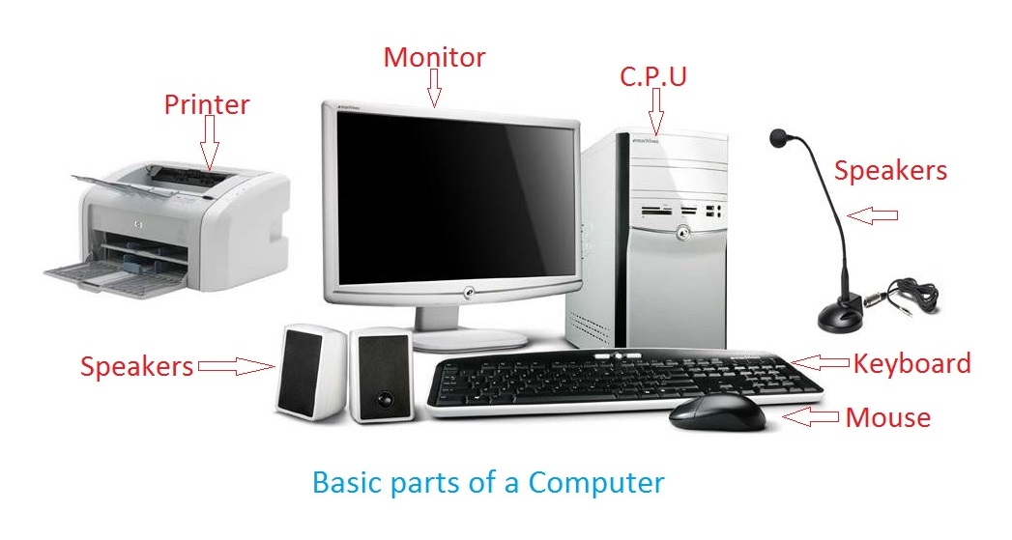

1. Central processing unit (CPU)
The CPU controls the computer processes and communicates with the other components of a personal computer. A computer's CPU may be one of the most complicated parts of the computer because of its intricacies. If a computer is experiencing CPU issues, a computer technician
may start by checking the fan and cleaning out any dust or debris inside the machine. Another step a computer technician may complete is verifying that power supply cables work. A CPU will not function properly unless it receives a signal from the power supply.

2. Monitor
A computer monitor is an electronic device that displays what's what programs are running on your computer so a user can see. Some computer technicians may wear anti-static gloves when handling computer monitors to avoid static electricity. They may also troubleshoot monitor issues by disconnecting it from the computer and trying a new power cord.

3. Mouse
A computer mouse can have a wire or is wireless and is an input device used to control a cursor on the computer monitor. A wired computer mouse has a cord that connects to a USB port on a computer while a wireless mouse has no physical connection with a computer system. Instead, a wireless mouse communicates using an adapter that is usually plugged into an available USB port and runs off its own batteries using Bluetooth technology.

4.keyboard

A computer keyboard is an input device used to enter characters and functions into the computer system by pressing buttons, or keys. It is the primary device used to enter text. A keyboard typically contains keys for individual letters, numbers and special characters, as well as keys for specific functions. A keyboard is connected to a computer system using a cable or a wireless connection.

5. Power supply
A power supply provides electricity to all components of a computer system. Typically, it's a power cord connected from the back of a PC tower into an electricity socket. A technician may troubleshoot the power supply by turning off the computer, unplugging and detaching the power supply cord or trying a new cord or outlet.

6. Cooling fan
Cooling fans are a computer's system to decrease overheating. Many computers have more than one cooling fan to help users who run their computer heavily, such as video streaming or gaming. A computer technician may need to fix a computer's cooling fan if a user notices their computer overheating. They may check for any damage to the blades and make sure that they are free from debris. Replacing computer fans can be a common troubleshooting solution for a technician.

7. Printer
This is a machine that produces copies of text or images on paper using ink. Popular printers include laser or inkjet and computer technicians may be skilled in troubleshooting issues across multiple brands and varieties. Computer technicians may service printers including verifying power is running to the machine. They may also check to see if the paper tray is full and ready for printing. Technicians might replace or refill any ink cartridges and toner.

